DENAH LOKASI OSCE (SKILLS LAB – GEDUNG BARU FK UNS LT.4)
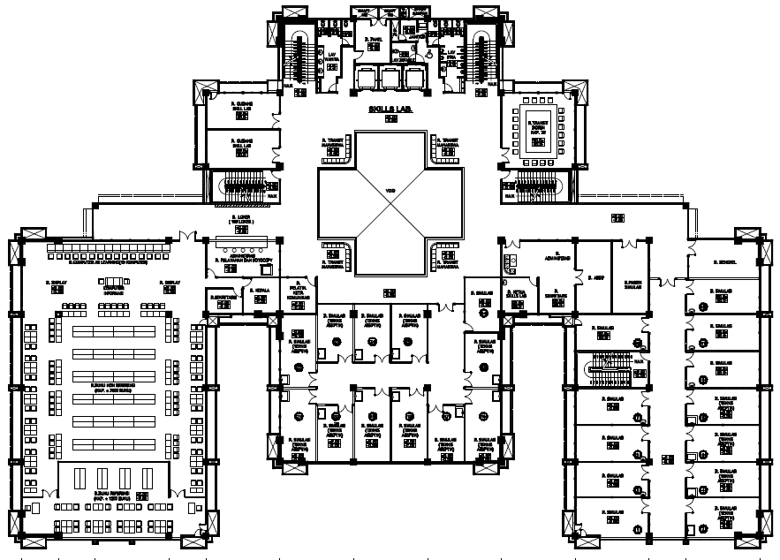
LOKASI
A
L O K A S I B
A
1
2
3
4
5
6
7
8
9
10
11
12
13
14
1
2
3
4
5
6
7
8
9
10
11
12
13
14
TOILET PA
TOILET PI
DENAH LOKASI REMIDI OSCE SEMESTER 4 PERIODE FEB-JUL 2016 LOKASI A

STATION GIN 1

R. A3

R. A4

KARANTINA STATION GIN 1

R. A7

STATION PAG

R. A1

STATION OBSTETRI

R. A2

KARANTINA STATION PAG

R. A5

KARANTINA
STATION OBSTETRI

R. A6

STATION
GIN 2

R. A12

TANGGA

R. A11

KARANTINA STATION GIN 2

R. A10

R. A9

R. A8

